Geometry Name_______________________________
Reflection Applications Date__________________Period_________
• A
B •
l
1. Two farms A and B are to be connected by separate wires to a transformer on a main power line l. Where should the transformer be located so that the minimum amount of wire will be needed?

m
A
B
8
6
12

2. (a) Find the point C on line m so that you create the shortest distance from A to B that touches line m.

- How long is AC + CB?

3. A camper out for a hike is returning to her campsite. The shortest distance between her and
her campsite is along a straight line, but as she approaches her campsite, she sees that her
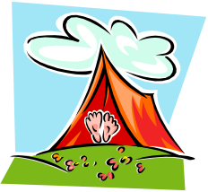
tent is on fire! She must run to the river to fill her canteen, then run to her tent to put out
T.
the fire. What is the shortest path she can take?

. C

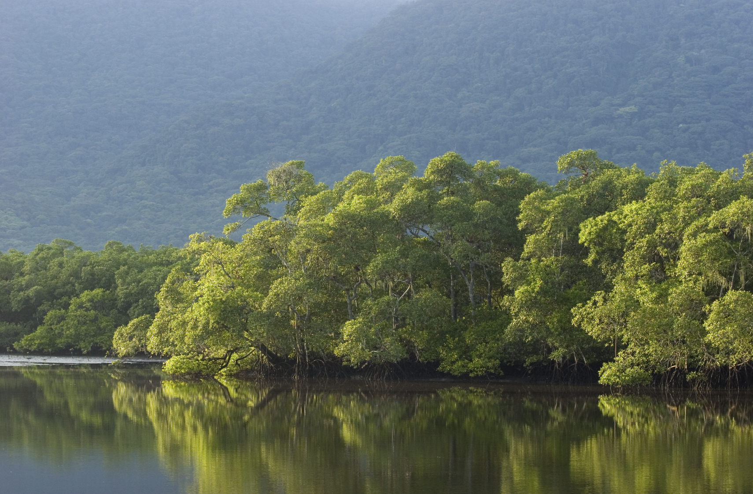

4. The figure at the right shows a par 2 hole on a miniature golf course. Where would you aim to make a hole-in-one? Can you do this by bouncing it off two sides?
Ball
•
•
Ball
•
•

5. The figure below shows the plan of a billiard table and the positions of the cue ball, C, and a red ball, R. Draw a one-cushion path from the cue ball to the red ball. How many such paths are there?
•
R
•
C

•
R
•
C
6. Draw a two-cushion path from C to R.
How many are there?

•
R
•
C

7. Can you draw a three-cushion path from
C to R?

Additional Problem in class if needed.

A rider is traveling from point D to E between a river and a pasture. Before he gets to E, he wants to stop at the pasture to feed his horse and at the river to water her. What path should he take so that he will minimize the distance he has to travel?
D
•
E
•
Pasture
River

What is the shortest mirror you would need on a wall in order to see your full reflection from your toes to the top of your head? Mark the length the mirror would need to be.
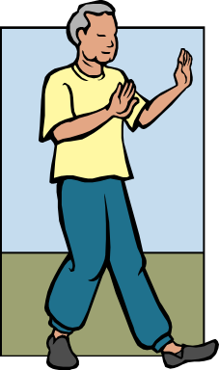
Top of Head

Eyes

Toes
Mirror

(The following are extra diagrams for billiard problems, just in case.)

•
R
•
C
•
R
•
C

